ENERGY POSTER PROJECT Collaborative Assignment – Lab Grade

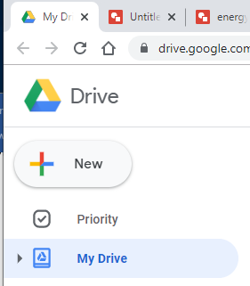  
Directions for Energy Poster Project

1. Login to Google Drive

(create Science Class folder there)

1. Create a Google Drawing   
   - click on **New**

- then find under **more** tab

1. Immediately name the document

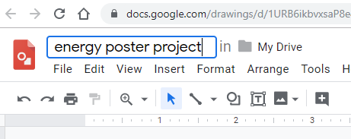Ex: Energy Poster Project



1. Click on Share 🡪 🡪

* then be sure and type all your fellow students names in and share drop down.

1. Be certain to store the Google Drawing in your My Drive – Science Class Folder
2. See example handout “Geothermal” by Cool Student for directions on the all specifics of how to complete Poster Assignment.
3. Make sure your poster has all the elements discussed, described and displayed in the example from class. All team members receive the same grade for this one.
4. When certain you are complete, print (in color) the document to be displayed in the classroom.